**Name: MATHAN RAJ T**

**DEPARTMENT: COMPUTER SCIENCE AND ENGINEERING**

**COURSE DETAIL: DIGITAL MARKETING**

**COLLEGE: DHANALAKSHMI SRINIVASAN INSTITUTE OF TECHNOLOGY**

**NM ID: C1E61A1F6D2138798524D4CD543FFFE4**

**ZONE: 12**

**ASSIGNMENT 1:**

Create a blog or website using Blogspot and WordPress. Customize

The theme design and post new article with 500 words

[**https://zorowears.blogspot.com/2023/08/zoro-wears.html**](https://zorowears.blogspot.com/2023/08/zoro-wears.html)

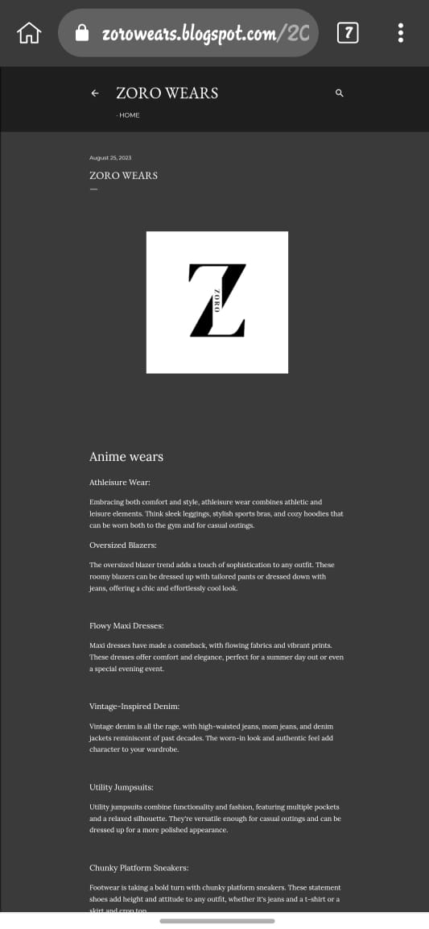

**ASSIGNMENT 2:**

Create a new Facebook business Page and Post one social media poster for your brand.

[**https://www.facebook.com/profile.php?id=61550791024149**](https://www.facebook.com/profile.php?id=61550791024149)



**ASSIGNMENT 3:**

Create and design a social media advertisement poster using Canva



**ASSIGNMENT 4:**

Create email newsletter design using MailChimp or Canva tool.

[**https://zorowears.blogspot.com/2023/09/blog-post.html**](https://zorowears.blogspot.com/2023/09/blog-post.html)

